Jagunmolu B Oke

[Email address]

Abstract

[Draw your reader in with an engaging abstract. It is typically a short summary of the document.   
When you’re ready to add your content, just click here and start typing.]

Racing simulation (driver behaviour)

Artificial Intelligence for Games

Table of Contents

Project Overview 2

AI-Driven Behaviour Characteristics 2

Car Model 2

Decision Making 3

Finite State Machine 3

Awareness (perception) 4

Fuzzy Logic and Set 5

Obstacle Avoidance 7

Pathfinding 9

Critical Evaluation 11

FSM Evaluation 11

Perception Evaluation 11

Fuzzy Logic Evaluation 12

Pathfinding Evaluation 12

References 13

Appendix 14

# Project Overview

This project is about racing cars, where AI embodies these car model and have their own unique behaviours for analysis and understanding the play space and make swift decision in a fun and playful manner. These behaviours include and not limited to Acceleration and Breaking, Environmental Awareness, Steering behaviour, Offensive behaviour, Defensive behaviour, avoidance behaviour, Overtaking behaviour and reactive behaviours.

This project aims to create an AI-driven behaviour model for a racing simulation using Unity neglecting fully car dynamics. These would be achieved using Applied mathematics (majorly Vector calculation, mathematical functions) and AI techniques (revolving around decision making then pathfinding and Autonomous Agents) to model these systems.

## AI-Driven Behaviour Model

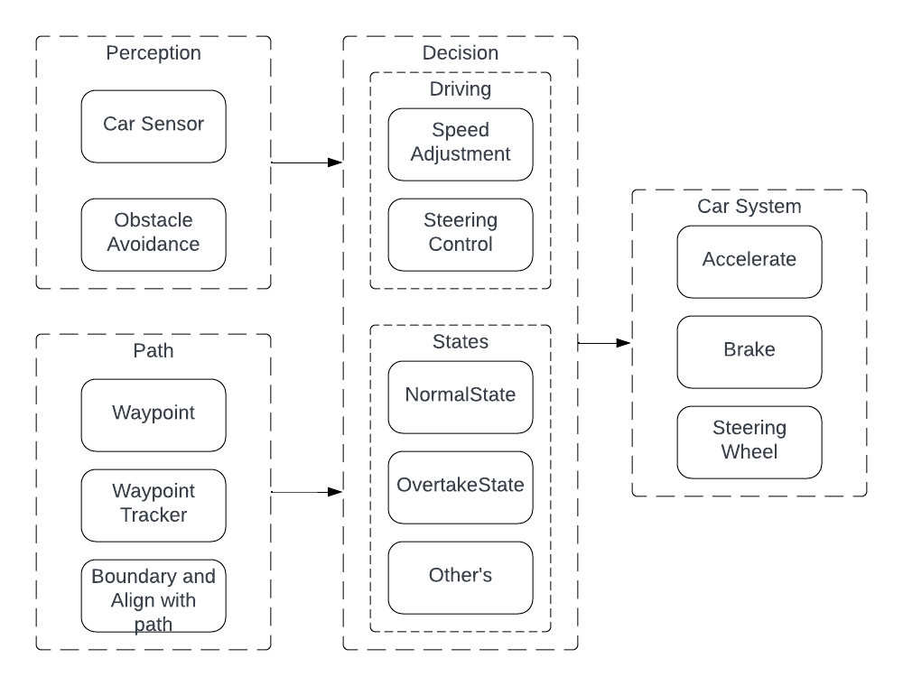The vehicle (Car system) is built upon the Unity Physics Wheel Collider, where torque is applied to them to move the vehicle or stop it.

Figure :Driver Behaviour System.

# Decision Making

Decision-making is primarily the backbone of creating a believable AI model behaviour, where the model can act and react based on its internal or external knowledge which the process in turn could affect the model's internal state and external environment state.

## Finite State Machine

The Finite State Machine (FSM) is the abstraction of multiple components of a system to a finite number of states, where only one can exist at a time and transitions are made between those states based on predetermined conditions.

FSM is used to model and manage the behaviours of the drivers; the following is an illustration of the use of FSM for a basic driver model.

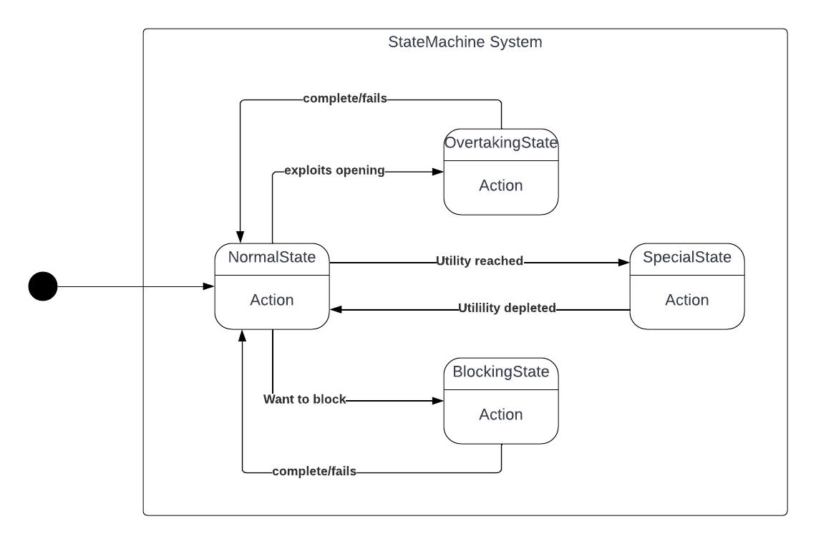 Figure 2 above shows the state diagram interaction for a basic driver model when conditions are checked using current gameplay situations with Boolean logic to decide whether a condition is meant to transition between states. But Special State use utility values to decide switch for example the Aggressive Racer special state is Aggressive state ranging from 0 – 10. Which increases or decreases over time based on the game state. If a threshold is met it switches to the state or out of the state.

Figure : Driver Behaviour State Machine UML.

|  |  |  |  |  |  |
| --- | --- | --- | --- | --- | --- |
|  | Opening (OnStart) | Special Utility < Threshold | Special Utility > Threshold | Potential Block (OnStart) | OnComplete |
| Normal | Overtake | - | Special | Block | - |
| Overtake |  | - | Special |  | Normal |
| Block |  | - | Special | - | Normal |
| Special | Overtake (Possible Ram) | Normal | - | Block (Ram) | - |

Table : Illustration of FSM driver model

Using FSM to model behaviours in games could get a bit complicated if the system being handled gets larger and more complex. Switching from one state to another, having multiple conditions to switch to another state. For a racing AI system, behaviours that are not large FSM will suffice to represent those behaviours (Tomlinson & Melder, 2014).

## Awareness (perception)

Awareness and perception are crucial factors for video game characters when making decisions. These factors help define what the character knows or doesn't know so that they can make informed choices. The AI collects information about the play space using specific variable calculations, as well as analysis through raycasting and vector calculations.

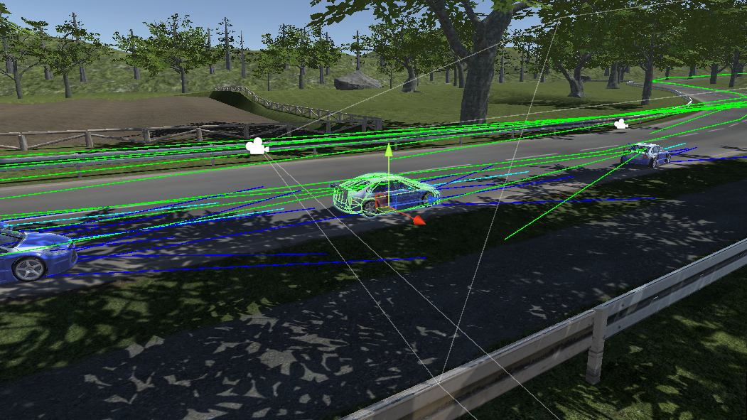Raycasting is used to predict potential collisions and opponents ahead of the AI. Different types of raycasting are utilized to retrieve information about the play space, such as distance to collision, opponent information, and distance to the next corners. Various types of collision raycasts are used for analysis, including single rays, single rays with parallel whiskeys, and single rays with cone angle whiskeys. Please see Appendix G, H and I for more details.

Figure : Multiple Raycasting

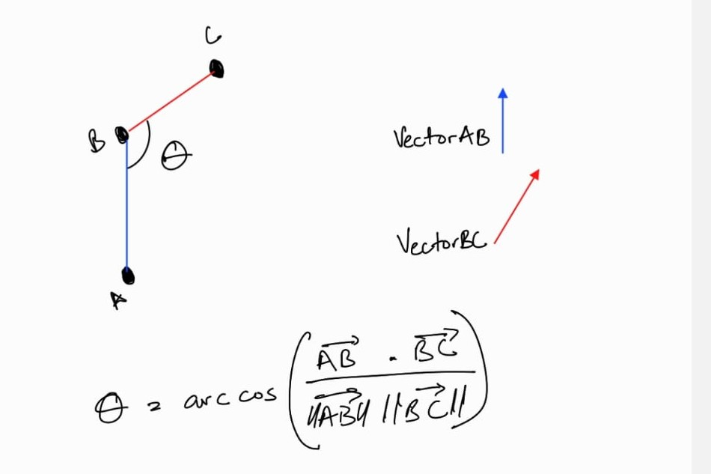Vector calculations are used to check distance, direction to points, angles between points, and more. One of the main uses of vector calculations is to calculate the distance to the next corner node, which is possible because the pathfinding system is node-based.

Figure : Three points angle calculation

This is achieved by testing the angle between three points (A, B, and C) to determine if there is a corner. The vectors A to B and B to C are calculated, and a dot product is performed to get the angle between them. The steepness between the two vectors defines the angle of the corner. Please see Appendix J for more details.

## Fuzzy Logic and Set

Fuzzy Logic is a mathematical tool that enables working with grey areas, not just black and white. It allows for modelling concepts such as “how true”, “pretty big” and more instead of just “true or false” as in traditional Boolean logic. AI characters can have deeper reasoning ability. (McCuskey, 2000).

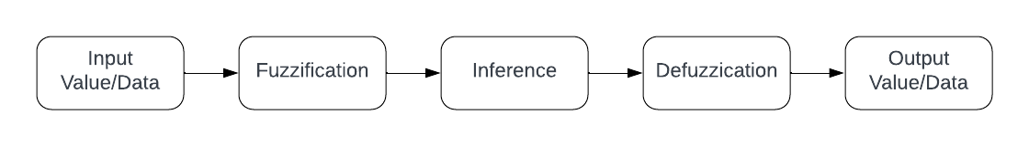 Fuzzy logic has been used to model the speed adjustment for each driver based on the distance to obstacles or corners and the current speed of travel. This approach aims to create a unique driver understanding of distance and current speed in their unique ways, and a decision will be made accordingly.

Figure : Driver Fuzzy System Process

1. The **INPUT VALUE/DATA**: hard values that provide specific information. The process takes in speed, distance, and the allowance for both speed and distance. Please see Appendix D for more details.
2. **Fuzzification:** where the system processes and determines the degree to which the input data belongs to a fuzzy set.

For the Driver Fuzzy System, the set is called DecisionRating and contains members of High, Average and Low. To rate input data (current speed and distance), the average is aggregated:

$$ratio=\frac{(currentValue-minimumValue)}{(maximumValue-minimumValue)}$$

To save time with complex mathematical calculations, the Animation Curve please see Appendix C, a unity tool was used to define the degree of member (DOM) to Decision Rating Set. This helps to create a unique behaviour across drivers by easily adjusting the animation curve corresponding to the members of DecisionRating.

To rate the DOM is each member, by the use of the method Evaluate() to the corresponding animation curve.

Degree of x = animation curve Of. Evaluate(ratio).

Where x is the member of DecisionRating, the degree of high, medium and low defines the belongs of the input data to the members.

1. **Interference:** where the system decides what the input data means, using 1 or 0 after fuzzification based on some provided rule set.

This model is to interpret “Big”, “Medium”, or “Small” and uses the fuzzified Data to decide to interpret the input data (current speed and distance) as Big, Medium, or Small. Please see Appendix A, for the Fuzzy Rule Set struct.

Big if the input data's highest DOM is high.

Medium if its DOM is average.

And Small if its DOM is low.

1. **Defuzzification:** where the system processes the output from the fuzzified set and Interference to a single data, computer-friendly information based on some extra rule set.

This model outputs the data as a single enum variable see Appendix E, SpeedAdjustment.

|  |  |  |  |
| --- | --- | --- | --- |
|  | Small Speed | Medium Speed | Big Speed |
| Big Distance | Floor it | Speed Up | Maintain Speed |
| Medium Distance | Speed Up | Maintain Speed | Slow Down |
| Small Distance | Speed Up | Slow Down | Brake Hard |

Table : Speed Adjustment determination based on Speed and Distance Relationship.

1. **Output:** The data is then ready to use by the driver. For this current program the SpeedAdjustment is used as a mini–HardCoded State machine (Hierarchical State Machine) as it is layered within the FSM system.

|  |  |
| --- | --- |
| Brake Hard | Full brake (1.0f), no acceleration |
| Slow Down | 0.5f brake, no acceleration |
| Maintain Speed | No brake, no acceleration |
| Speed Up | No brake, 0.5f acceleration |
| Floor it | No brake, full acceleration (1.0f) |

Table : Functions of Speed Adjustment enum

# Obstacle Avoidance

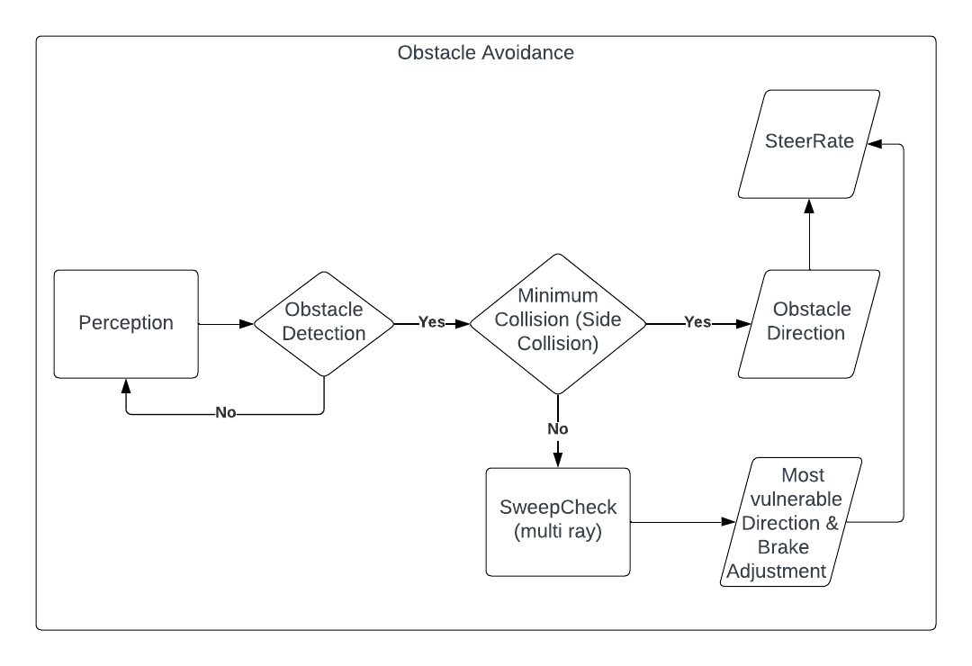 Predicting collision or threat is a very useful thing to be implemented into an AI System, that involves more than one AI agent (DaGraca, 2017). The Obstacle Avoidance System is heavily reliant on the Awareness set up for the system.

Figure :Obstacle Avoidance System Flow.

The Figure shows the steps for individual AI driver model processes to avoiding threats to decision making.

1. 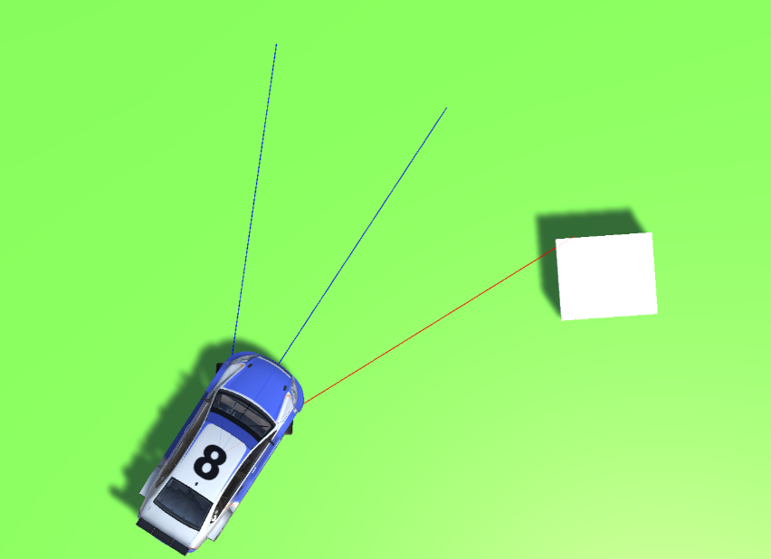During **Perception:** The system collects information about the environment using awareness techniques.

Figure : Environmental Awareness

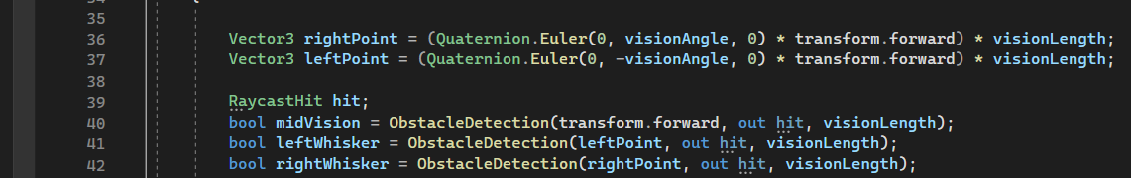The single ray and two angled whiskies are used to detect where obstacles are for potential collisions.

Figure : Collision Ray Construction

The figure above shows the mathematical construction of the rays based on the forward of the vehicle and returns a “true” Boolean value on detection.

1. If **Obstacle is Detected:** when one of the raycast returns true, the minimum collision is decided based on the if the obstacle is on the two side whiskeys. A Maximum collision is predicted if the middle ray returns true, which triggers a **SweepCheck**.
2. **SweepCheck:** SweepCheck returns the direction of the most danger as integer -1 or 1 for left and right respectively. The check is performed by shooting multiple rays from left to right within the side whiskeys.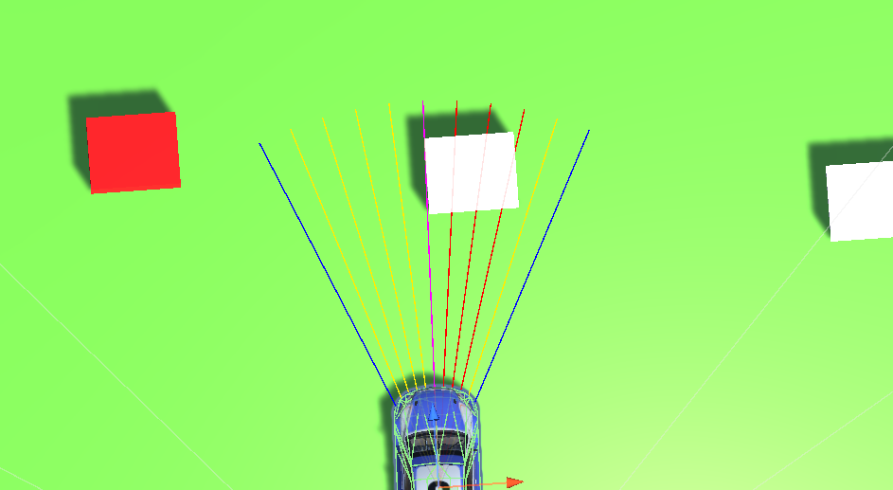

Figure : Sweep Rays for Collision Detection

From Figure 9 above, the yellow-ray indicates a false collision and a red for true collisions.The direction of danger is computed based on the side with the most true collision. See Appendix F, for the sweep technique algorithm.

# Pathfinding

The pathfinding for the driver AI is defined by using traditional Waypoints systems where the nodes are carefully hand around the track circuit which can be used to guide the driver around.

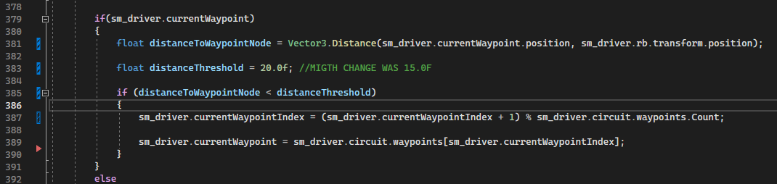The nodes are stored in a list of transforms, and the drivers can keep track of the current node using the index of that node in the waypoint. Then if the driver has reached a specified threshold to the node the current node integer value is incremented by one.

Figure : Update Current waypoint Index.

In the Car Engine, a function Move() with takes in parameters acceleration (0-1), brake (0-1) and steer(-1 to 1) is used to navigate the vehicle along the track with the current waypoint transform and some angle calculations the driver determine the steer rate and calls the Move function. Please   
See Appendix K, L and M for more details.

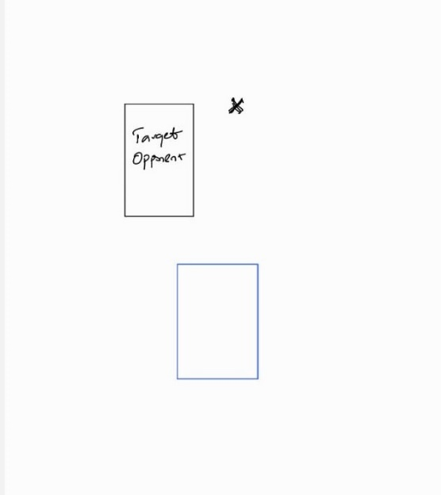Overtaking Path, for overtaking a four-node instantaneous path is calculated based on the main circuit path. The first node point is decided based on the dominant side, and some offset to the opponent overtakes the target.

Figure : Most Dominant Side

For the other three points, the current waypoint is taken into consideration and the first node is compared with it and the instant direction of flow.

The instant direction of flow = next waypoint node – current waypoint node.

If the first node, is behind the current waypoint node use the instant direction of flow else calculate the next direction of flow. See the illustration below.

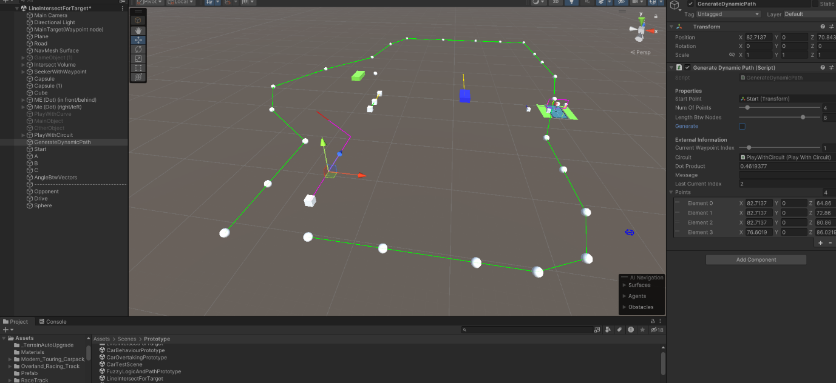The Green line illustrates the flow of the main path, and the magenta line illustrates the dynamically created path mimicking the flow of the main path. Please see N, O, P, Q and R for more details

Figure : Dynamic Path Creation

# Critical Evaluation

## FSM Evaluation

Having an FSM system to model the behaviour of the driver with the provision of an event of Enter, Update, Exit.

The Enter Event helps to facilitate the initiation of parameters of different states on Enter. And the Exit Event for functions that need to be performed before exiting. Came in hand for Transiting to OvertakingState all overtaking data are collected on Exit and passed to the Overtake State if Valid. Please see Appendix S and T.

## Perception Evaluation

A quick perception analysis is vital for fast variables, where the use of just a line does not cut and it introduces a blind spot. Which is like “The Corner Trap” where there are several experimented solutions like bounding volumes and adaptive fans (Millinton, 2020).

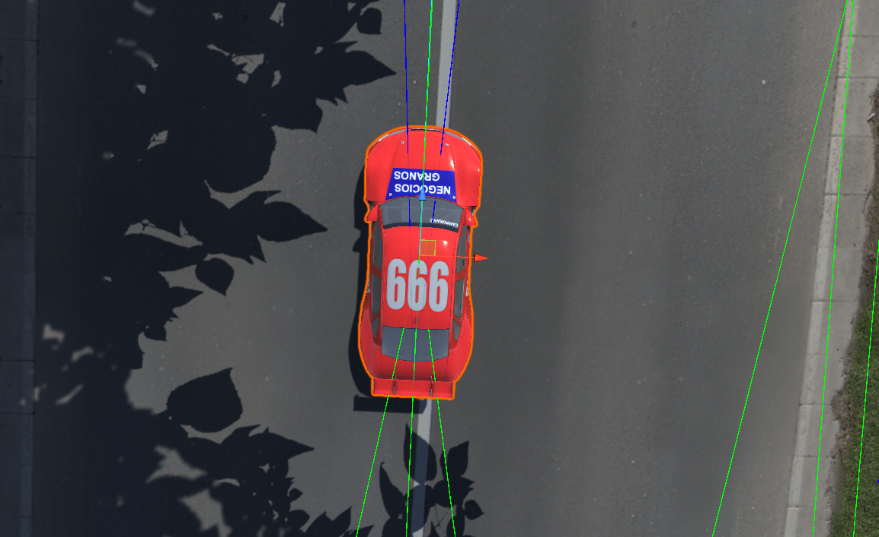For Vehicle avoidance, the adaptive fans were a quick solve used based on the speed of the driver where the whiskey has a minimum and maximum angle.

Figure : Minimum Blue-ray angle

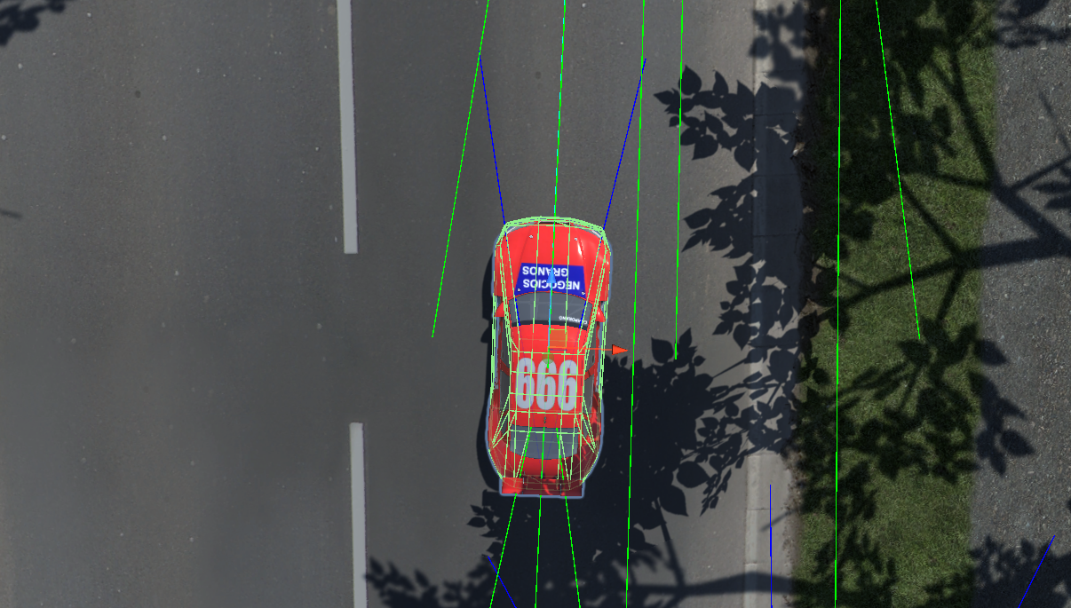

Figure : Maximum Blue-ray angle

## Fuzzy Logic Evaluation

The fuzzy system creates variations in the movement-based distance to corners, and current speed.

Area of Improvement

1. Feed the system more variable (potential collision, distance to next vehicle)
2. In depth Data-Driven design: Hard-coding the function membership during interference and defuzzifying human friendly data, prevented more control for variation.

## Pathfinding Evaluation

Different Path planning was tested Flow Field, waypoints with path tracker.

Flow Field: A flow field would have been a good fit but with limited time was not able to complete the implementation. Which could provide a smoother movement for drivers that optimizes speed and efficiency but could also be computationally expensive. Please See Appendix U and V.

Path tracker: was designed as an add-on to the waypoint system to create dynamic procedure steering behaviour so the drivers would have a bit of variation while following a path.

Steer Vehicle Wheel

If the driver forward not is parallel to the path tracker

If the driver position is out of bound to the path tracker

Steer towards the path tracker

Continue

This method created an unnatural and unbalanced behaviour which resolved back to the waypoint system. Please See Appendix W and X.

Waypoint Node: Simple gets the job done and is not computationally expensive.

PROBLEM WITH PATH ANGLE CORNER CHECK

# References

DaGraca, M. (2017). *Practical Game AI Programming.* Packt.

McCuskey, M. (2000). Fuzzy Logic for Video Games. In M. Deloura, *Game Programming Gems* (pp. 319 - 329). Boston: Charles River Media.

Millinton, I. (2020). *AI for Games.* London: CRC Press.

Tomlinson, S., & Melder, N. (2014). An Architecture Overview for AI in Racing Games. In S. Rabin, *Game AI Pro* (1st ed., pp. 10-19). A K Peters/ CRC Press.

# Appendix

Appendix

Appendix

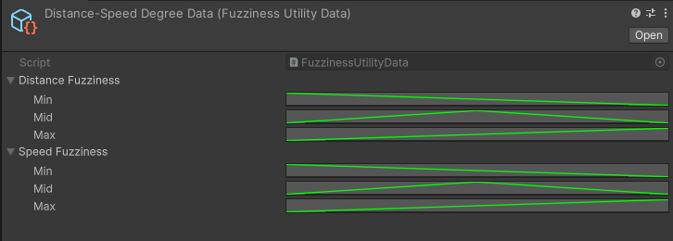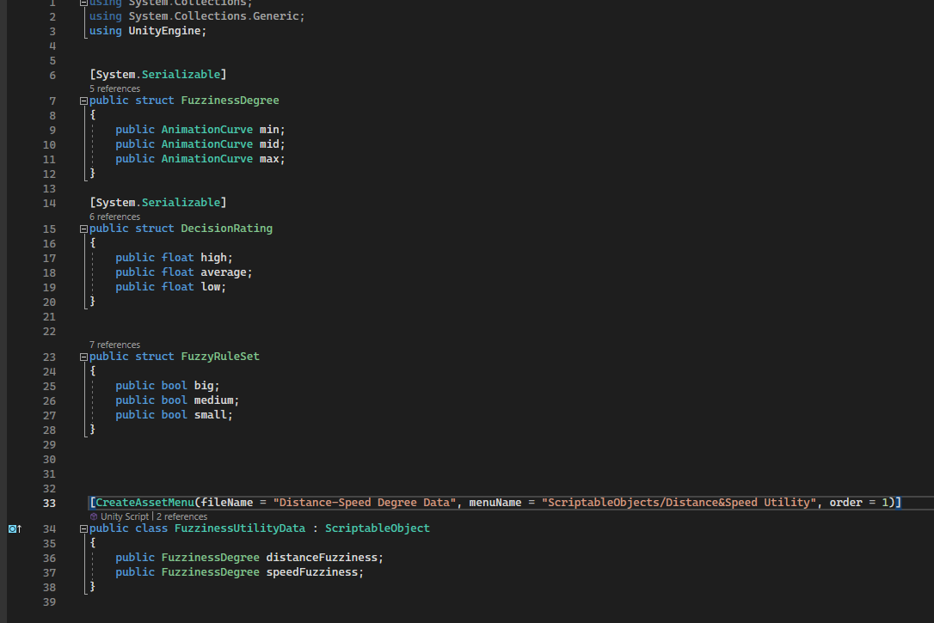

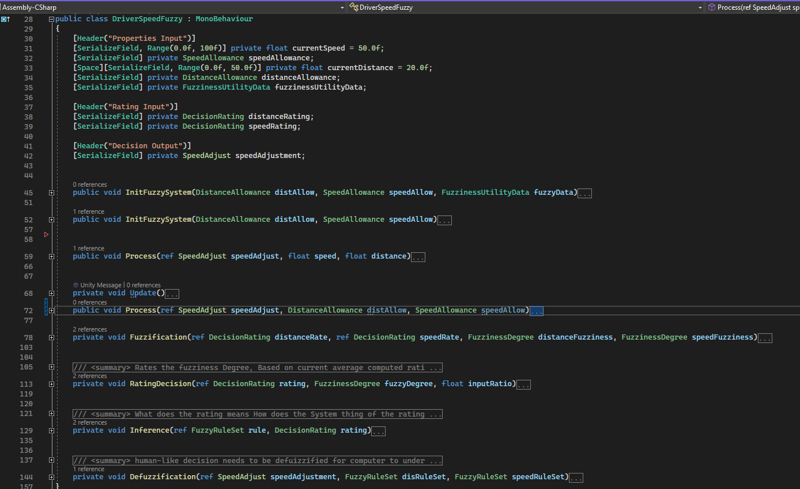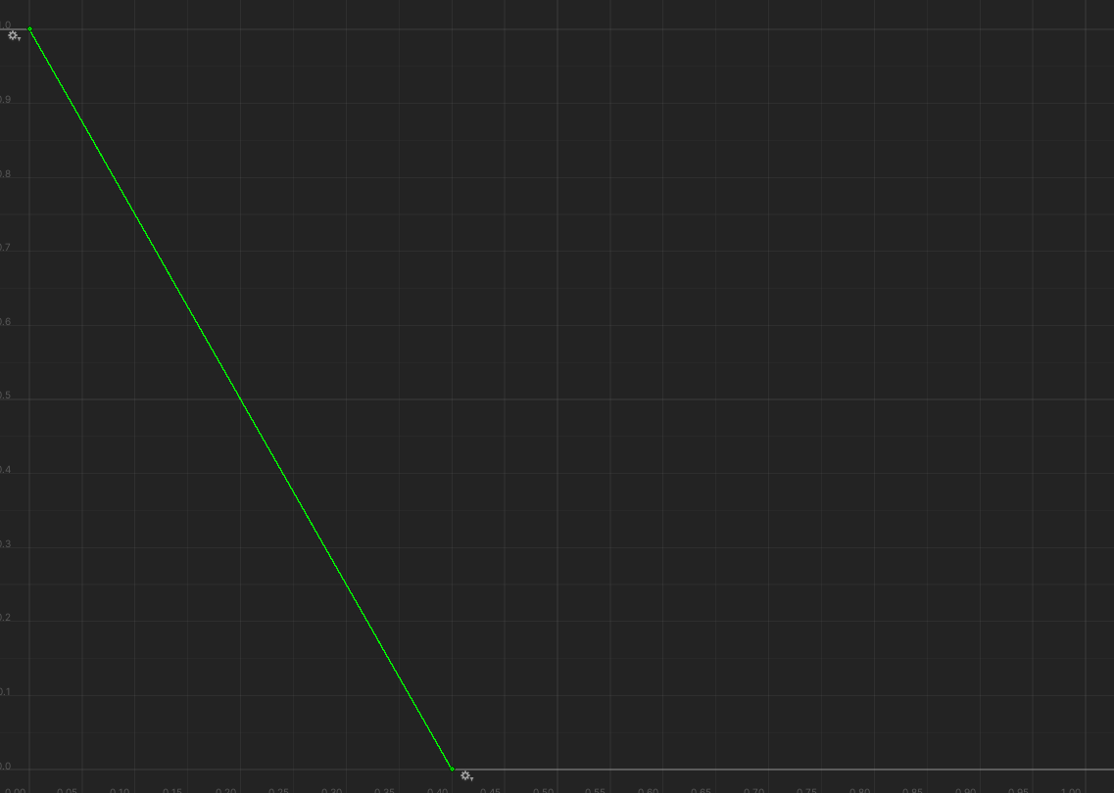

Appendix

Appendix

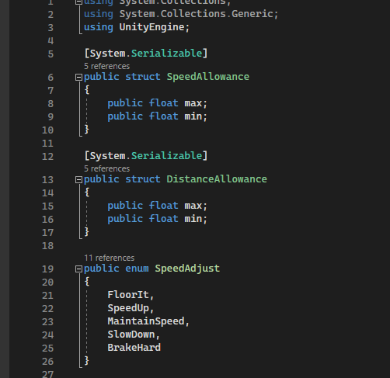

Appendix

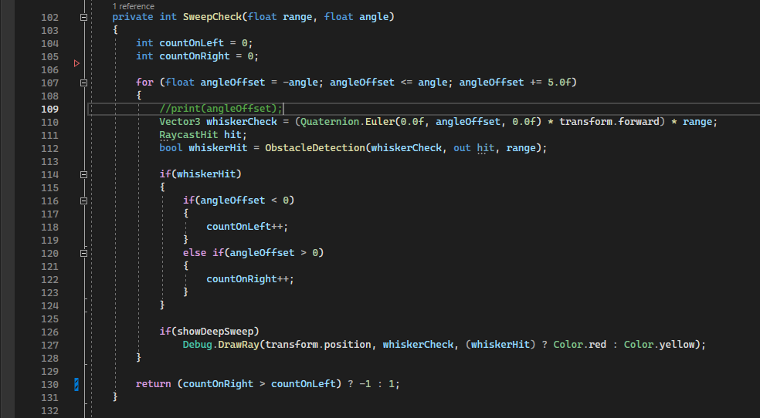

Appendix

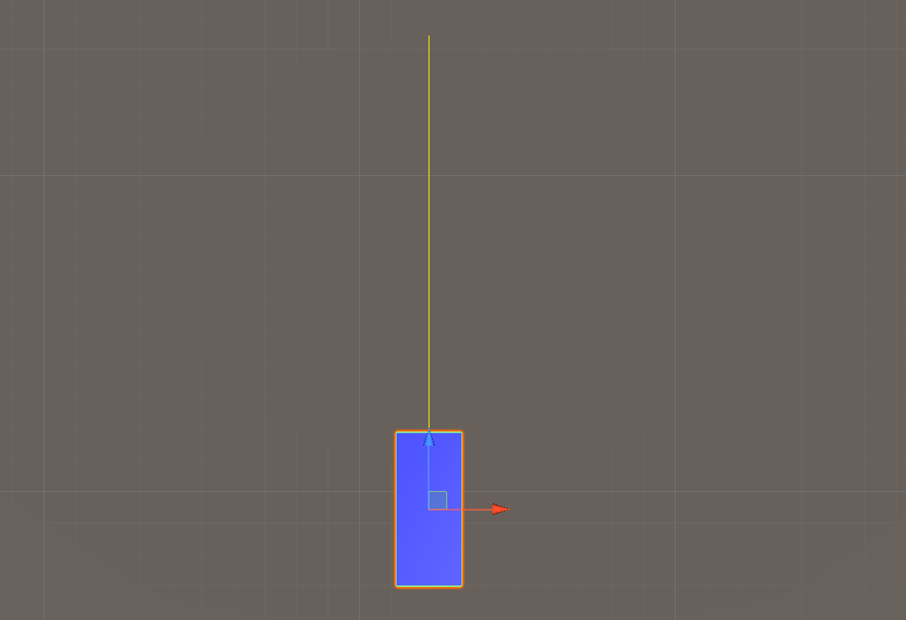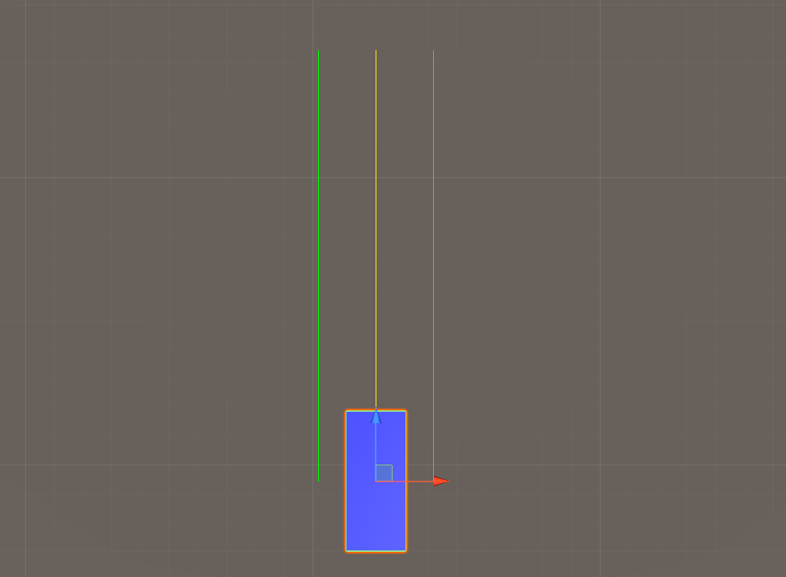

Appendix

Appendix

Appendix

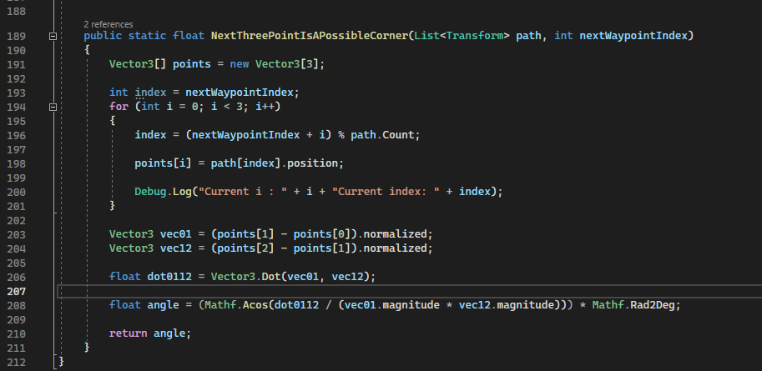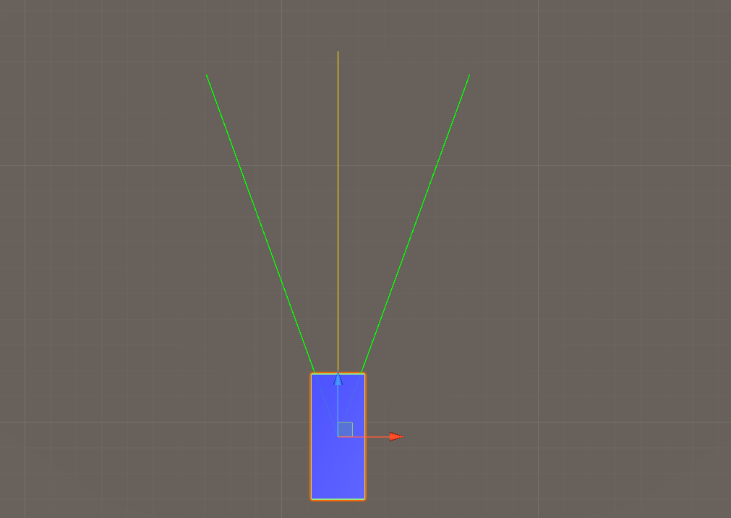

Appendix

Appendix

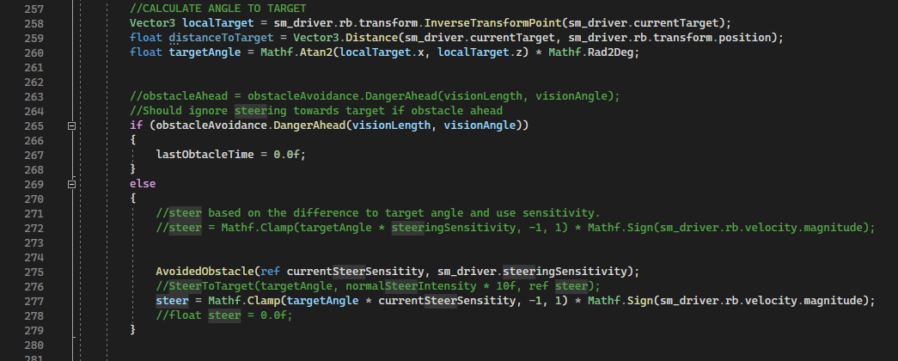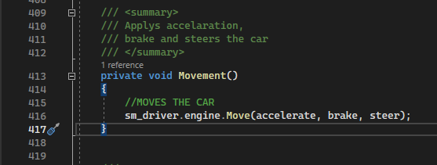

Appendix

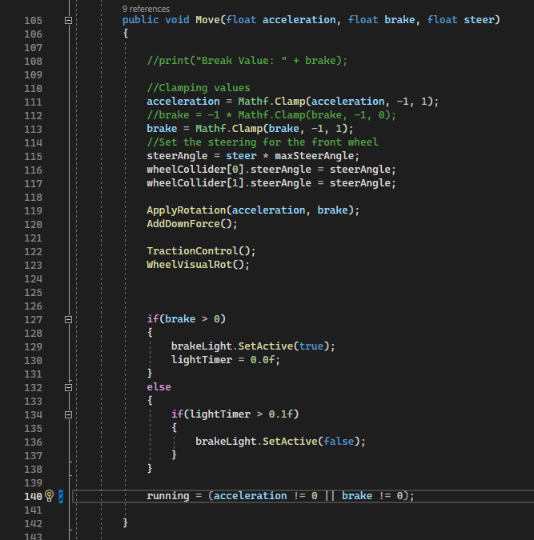

Appendix

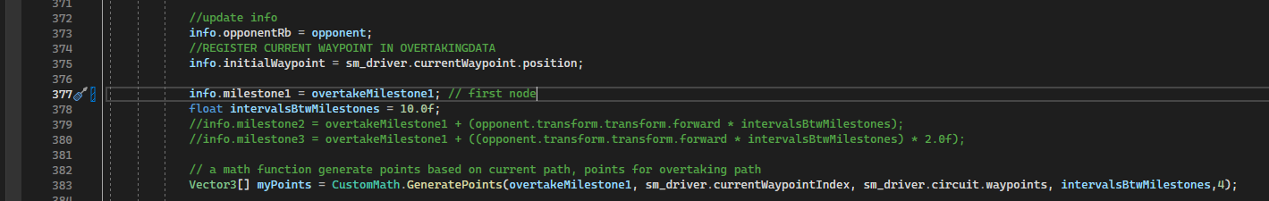

Appendix

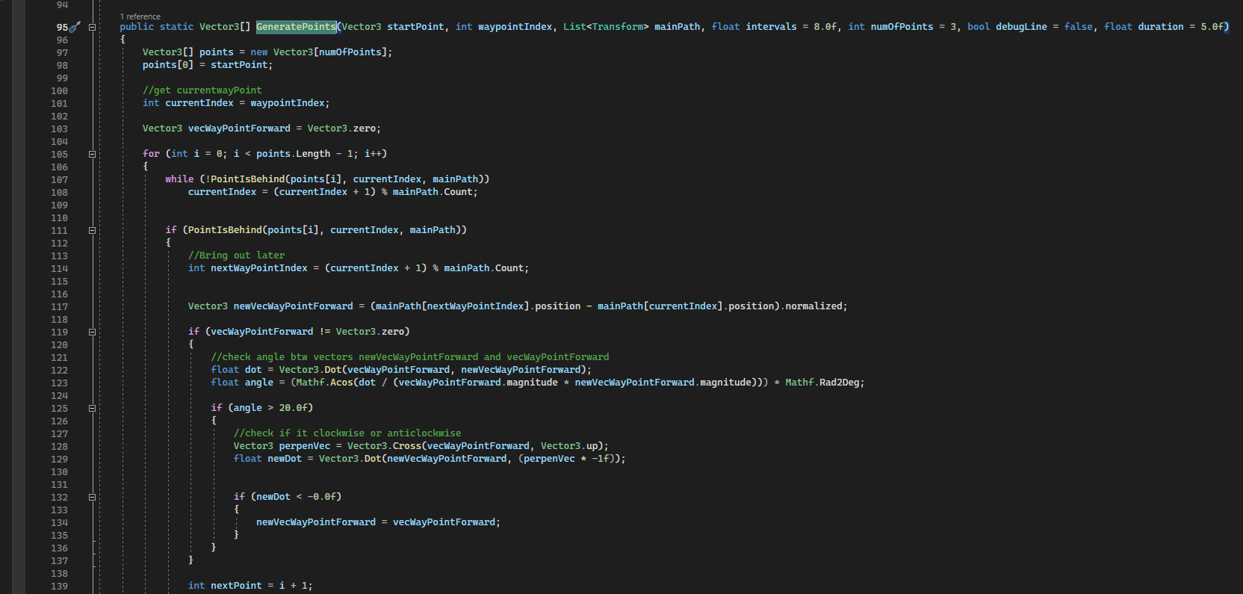

Appendix

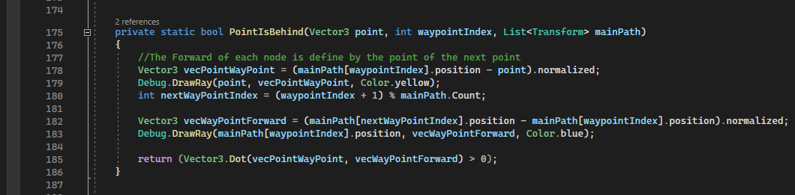

Appendix

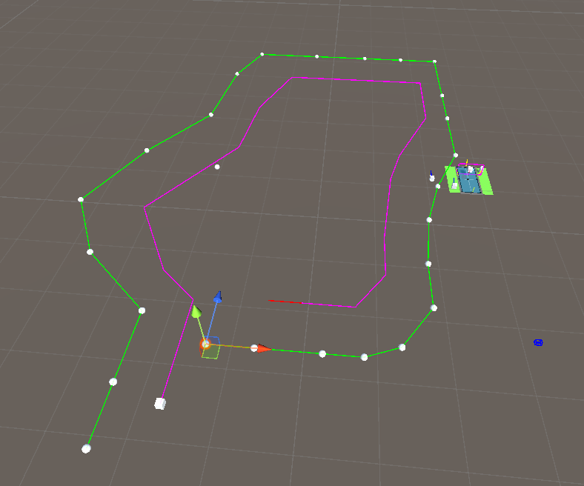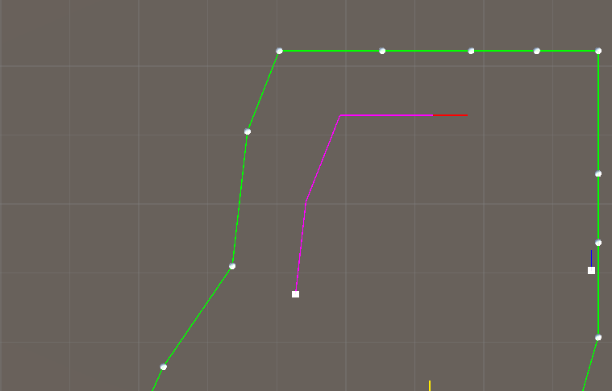

Appendix

Appendix

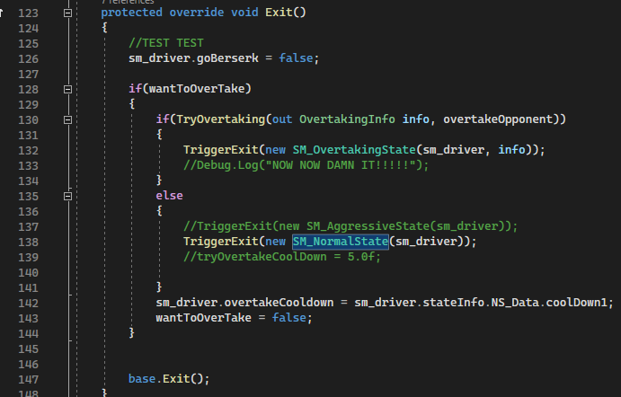

Appendix

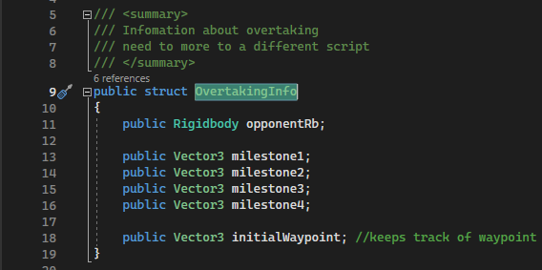

Appendix

Appendix

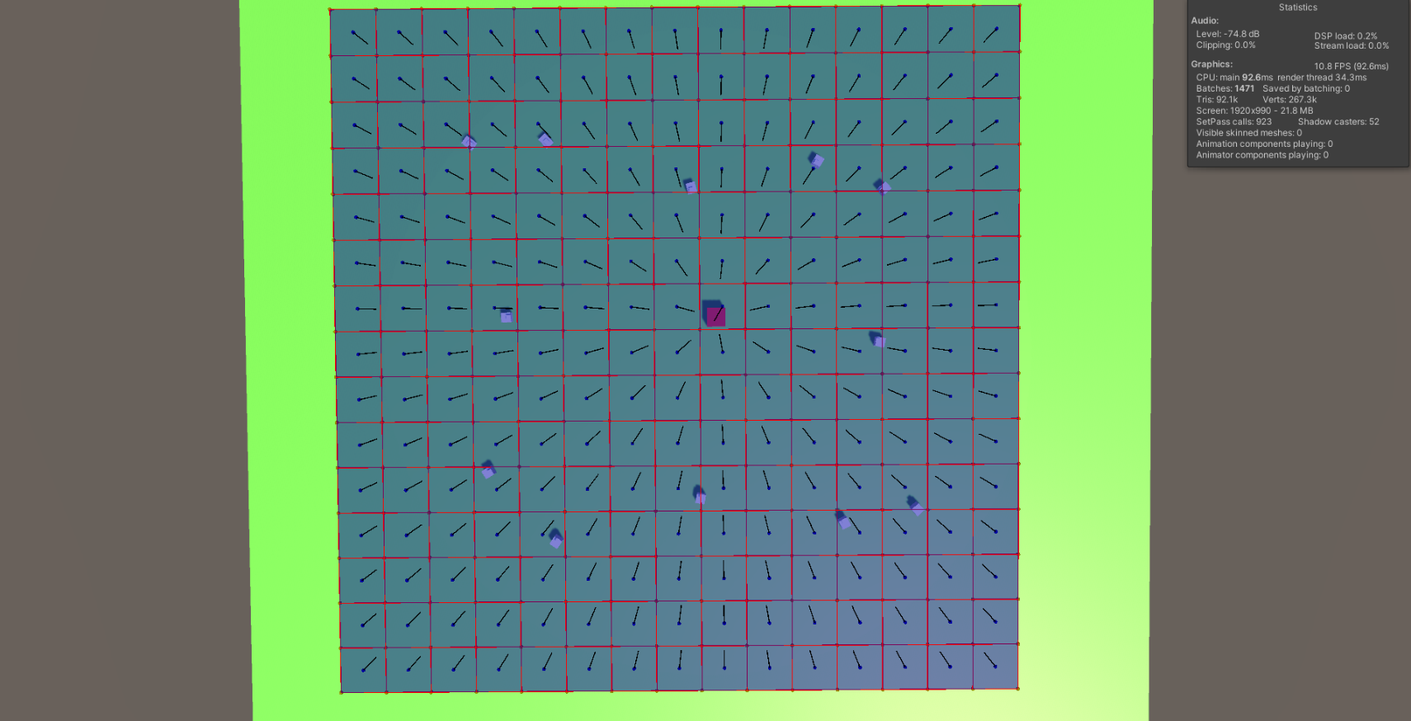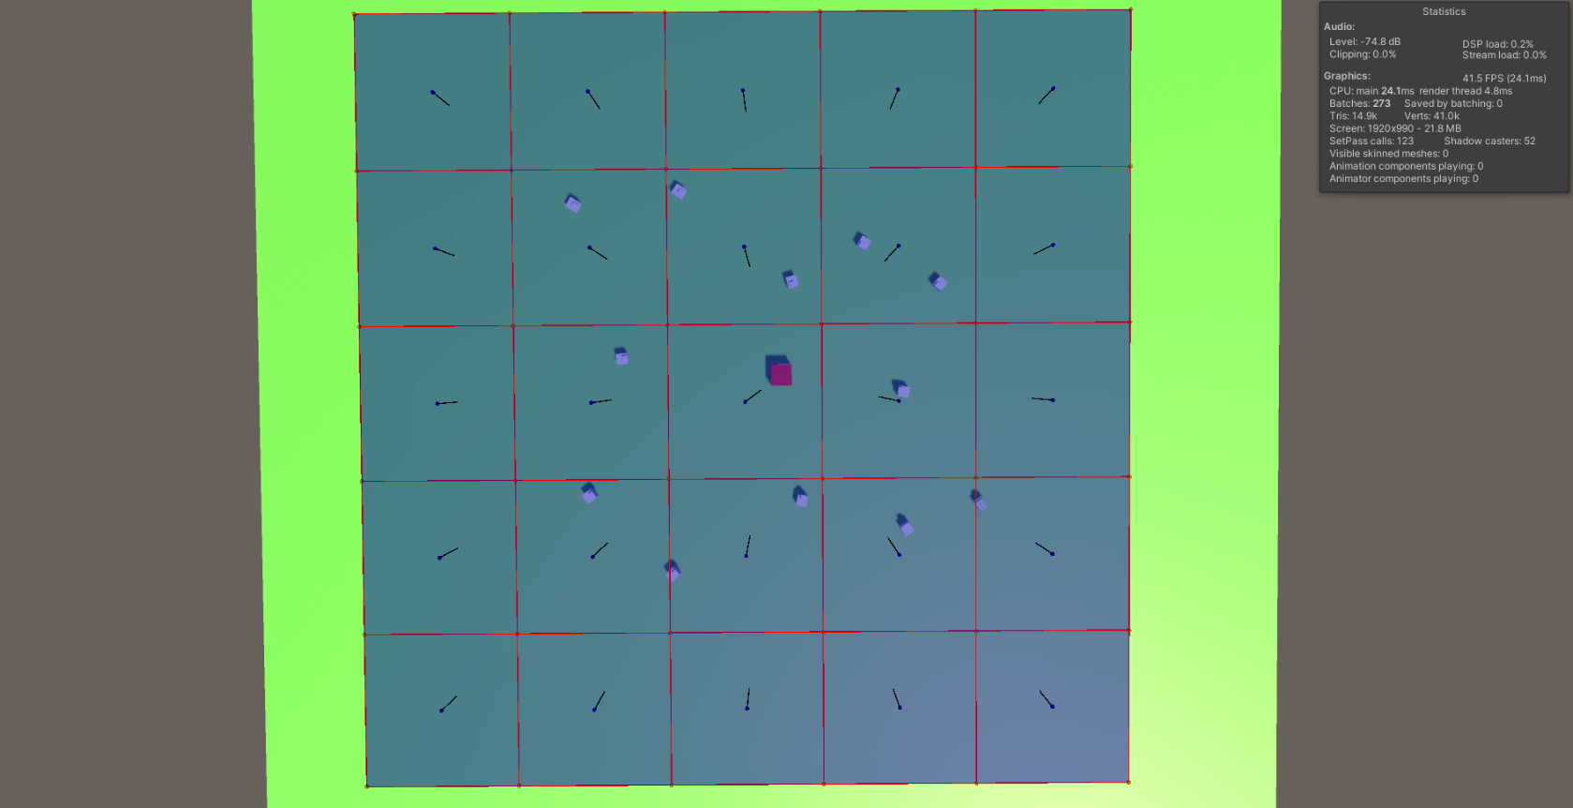

Appendix

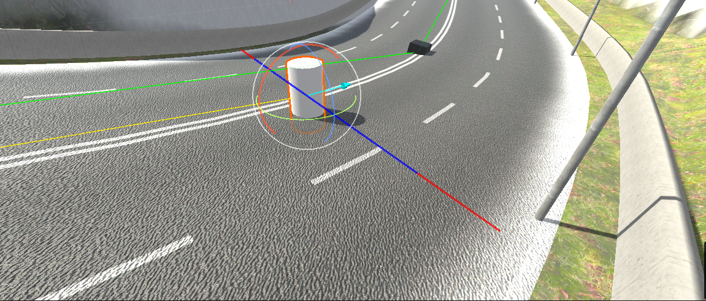

Appendix

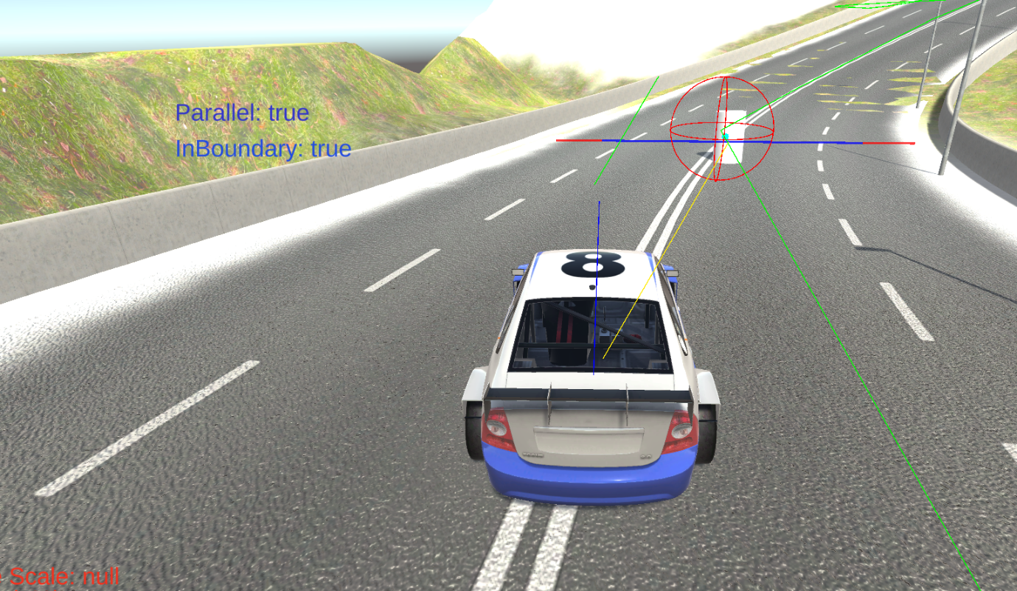

Appendix